HTML BASICS
In this file there will be basic commands and key-binds about html and all the basics needed to know.
First of all
<html> the opener
the content of the site
</html> The closer.

Everything within these lines of code is the content of the site.

What does the content contains ? :
1.Body- the paragraphs the text and all of the things that the end user can see.
2.Head- All the information that the user usually cannot see, like links calculation etc.

Html Attribute- it is an attribute that we give too a tag.
<tag-name attribute1=”value 1” attribute2=”value2”>

Tags in the Body.
- <h1,h2,….> some kind of head line </h1,h2,…> - this is the headlines in your site.
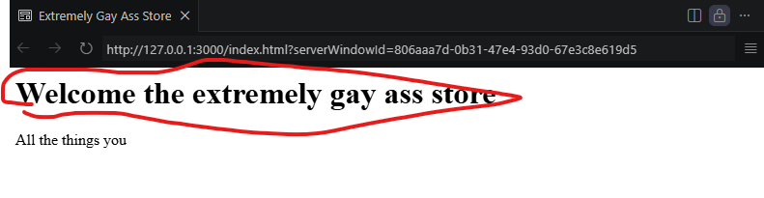
- <p1> a paragraph that contains some kind of text </p1>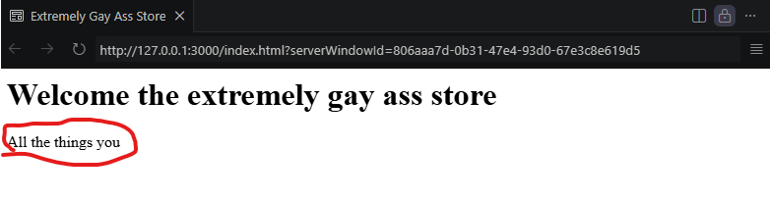
- <br> - a tag that makes a spaces between paragrahps
- <hr> - a tag that an horizontal line or rule. That seperates paragraphs

- <ul> unordered list- inside the command there will be <li> list item they both have </>
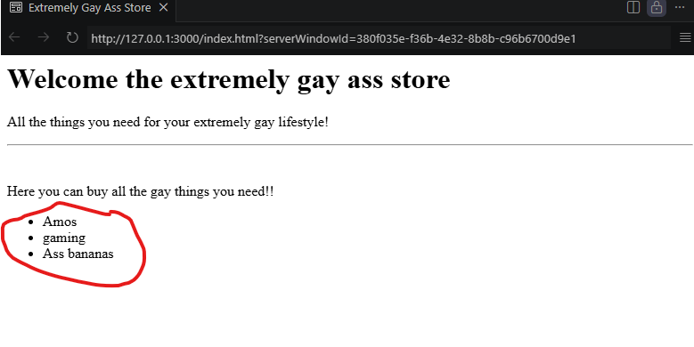
- <ol>- and ordered list with 1, 2, 3, etc.
7.<table>- a table inside the table there is <thead> a headline inside the headline the there is only <th> table head and <td> table rule and table content.
After this comes the body of the table <tbody> inside the body there is the same things <tr> and <td>.

- <a>Anchor it’s a link for another tab in the site or another site,
For example <a> amos gaming site </a>
Inside the there is usually a link as an attribute
For example <a href=” somekind of link”>

- <img> image comes from either the internet, or an image from your own pc.
You use after the line src as an attribute it is source.
In order too add a pic from your pc you need too open a file in the Code software,
And the src name will be the name of the file then a / then the name of the picture.
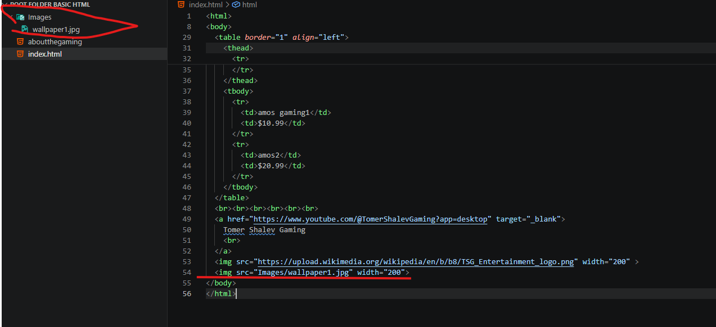
You need too add the pic too the file in the pc itself not via the coding software.
- <span> a text that is not in a paragraph,
- <div> Devision a tag that combines a few images picture pargraphs as you would like, and the point is too give all of them a same attributes.

- <iframe> it shows a site from another site, you use with it attributes such as weight, and src it’s the same as links and pictures, it can be used too show youtube videos in your site.
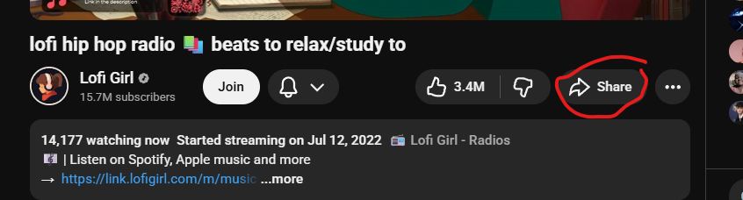
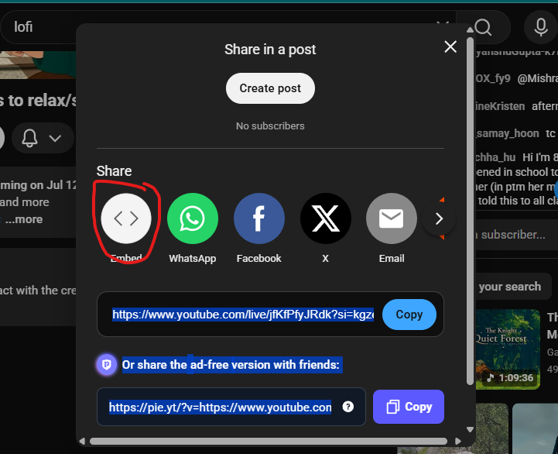
- <b>/<strong> making text bold

Tags in the Head:
- <title> A title </title>- this title is the name of the tab of your sight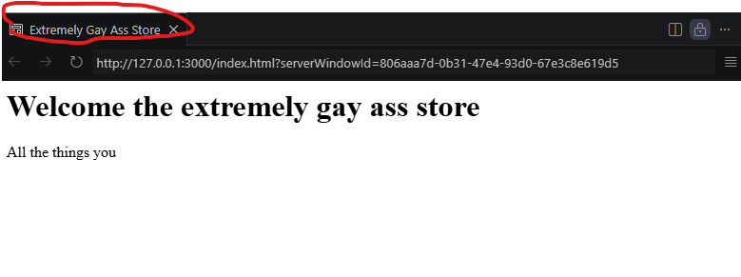
- There is a tag that doesn’t have an end </> it doesn’t have the closer command.

- <meta>- this is command that give info for the meta search engines.
For example if I want that people who search my site will find me I add info:
<meta name=”description” content=”ass, gay, amos gaming etc”>.
4.<link> used too add an icon for the tab, this is an example
<link rel="icon" type="image/png" href=https://static.thenounproject.com/png/5503551-200.png>
- <form> a from that’s is purpose is to take info from the user, the tag contains text files, choosing file, file of dates. This tag gives you the option too send the info too a src in the end.
The attribute action in form is where does the form is sent too
In from there is
<input> which is what type if info given,
And <label> what label do we give too the info sent this is what the user sees
And <button> which by default without writhing an attribute sends too the Action=”” that was configured.
There is also instead of input <select> which is a list of <option>’s
Use the attribute <option disable selected> if you don’t want people selecting some option for some reason, don’t forget too add an attribute too <select name=”something”> cause it will not work without it. Not only in Use it always in Input Selected Text Area!!!!!!

Attributes
- Width- the width of a line for example. For example <hr width=”100”>
- Type- for example in ul <ul type=”squre”> it will make the dots of the lists squared
- Border- it is used in <table> is is to make a border in the table
- Align- to align in the left right or center
- Href- head refrence- another link for another site in <a>
- Target- when I open the link in my sight it will not overlap my site it will open another tab,
- Id- its basically an identification, for other languages in the platform that helps JavaScript or CSS identify the tag that you gave this attribute too. And too other tags as well, in html itself you use ID in one of the tags and FOR for the one you want too combine it.
- Required- used in forms
- Minlengh
- Maxlengh
- In a form ALWAYS put a method=”get” actually you can put dialog if it’s a calculator for example, you don’t want the info too get too the server.
12.Don’t forget too put always Value In radio type Inputs.

Bugs and trouble shooting.
When something is highlighted in red it means something is wrong with it it will be shown usally in the problem line if not it usually means that the feater you added is a design feater that can cause problems too CSS.

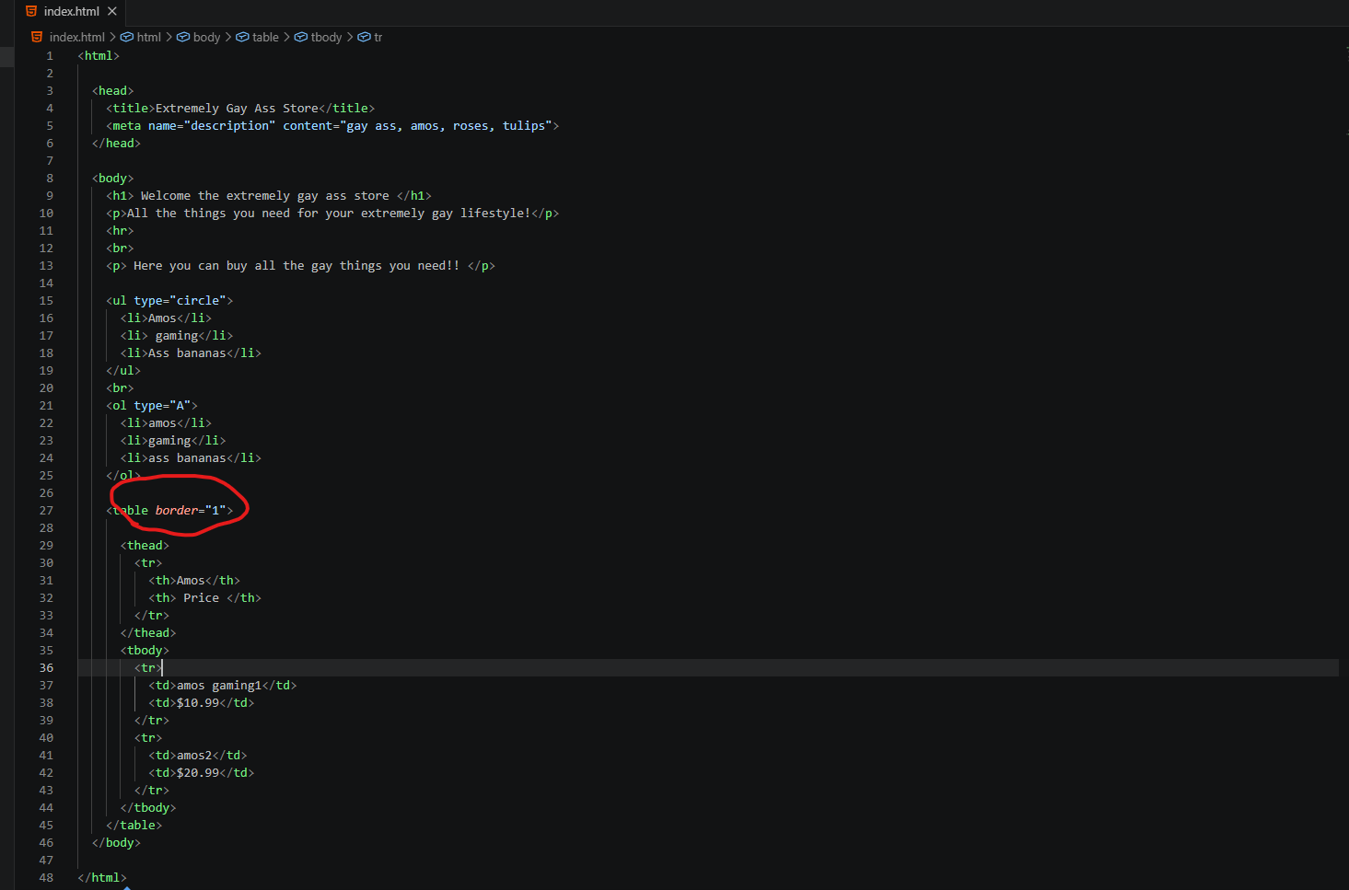
Here there is a attribute named border- it borders the table and its red it doens’t show in the problem tab, it means in can overlap with CSS and make visual problems.

#if you have a red inside any kind of body or tag it means that inside it there is a problem

